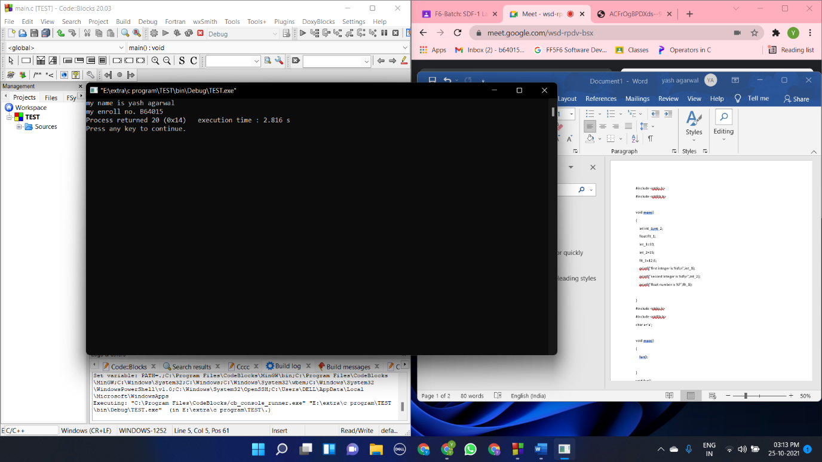Question 1

#include <stdio.h>

#include <stdlib.h>

void main()

{

printf("my name is yash agarwal \n");

printf("my enroll no. B64015");

}

Question 2

#include <stdio.h>

#include <stdlib.h>

void main()

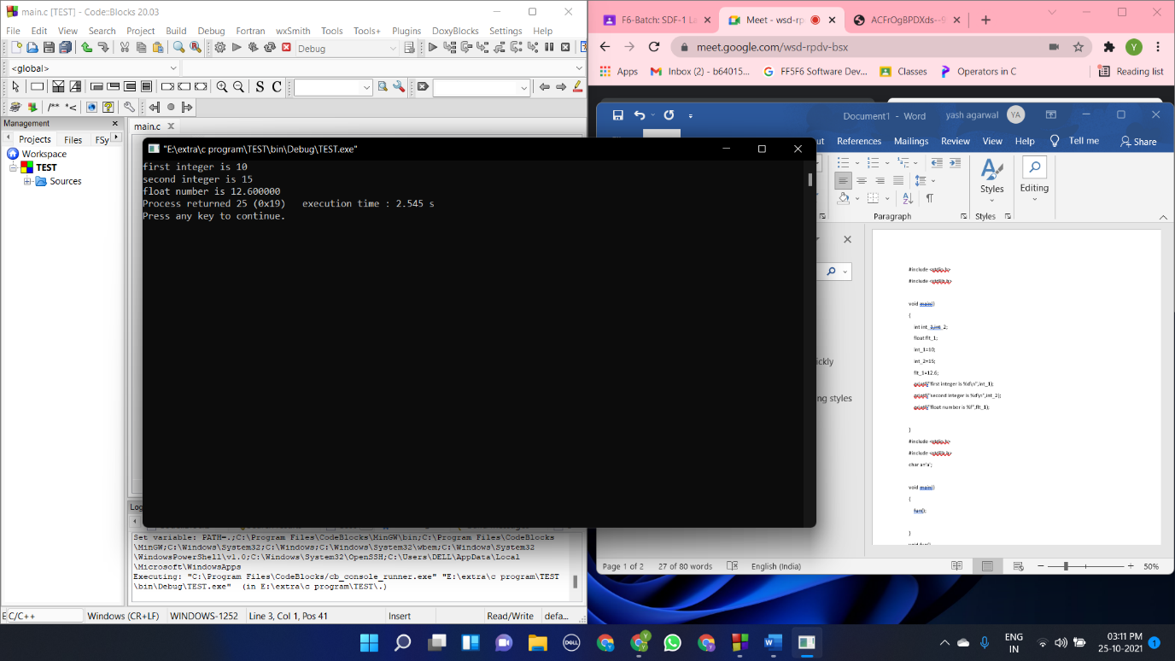{

int int_1,int_2;

float flt_1;

int_1=10;

int_2=15;

flt_1=12.6;

printf("first integer is %d\n",int_1);

printf("second integer is %d\n",int_2);

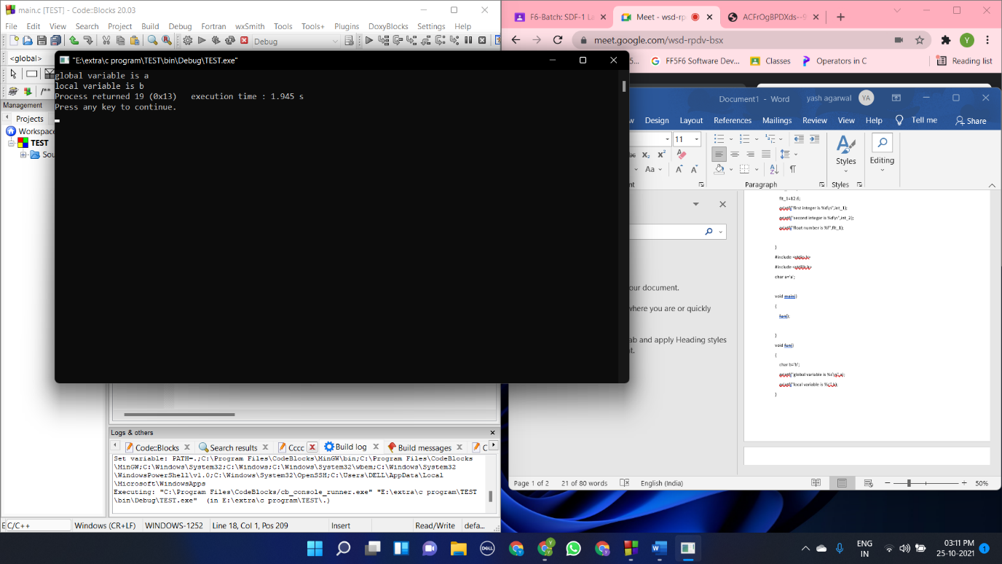 printf("float number is %f",flt_1);

}

Question 3

#include <stdio.h>

#include <stdlib.h>

char a='a';

void main()

{

fun();

}

void fun()

{

char b='b';

printf("global variable is %c\n",a);

printf("local variable is %c",b);

}

Question 4

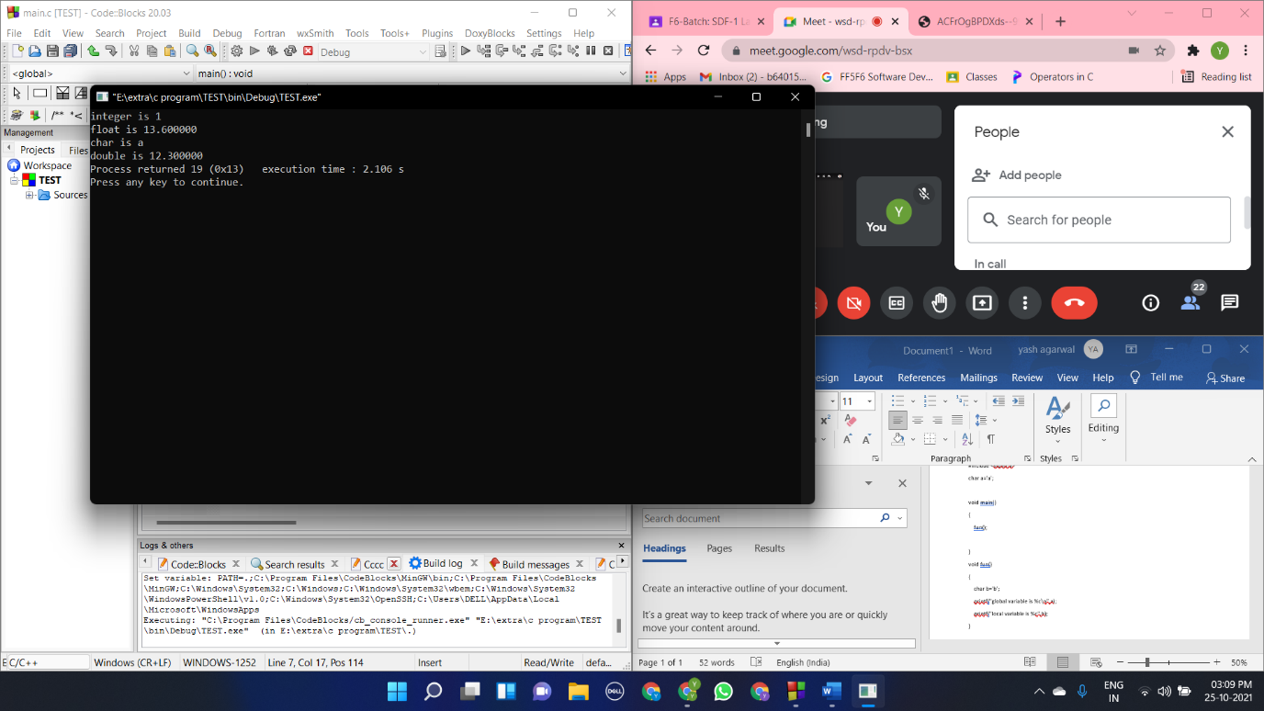#include <stdio.h>

#include <stdlib.h>

void main()

{

int integer=1;

float flt=13.6;

char cha='a';

double dou=12.3;

printf("integer is %d\n",integer);

printf("float is %f\n",flt);

printf("char is %c\n",cha);

printf("double is %lf",dou);

}

Question 5

#include <stdio.h>

#include <stdlib.h>

void main()

{

int a ,b,sum,diff,mult,divd;

printf("enter the first integer:");

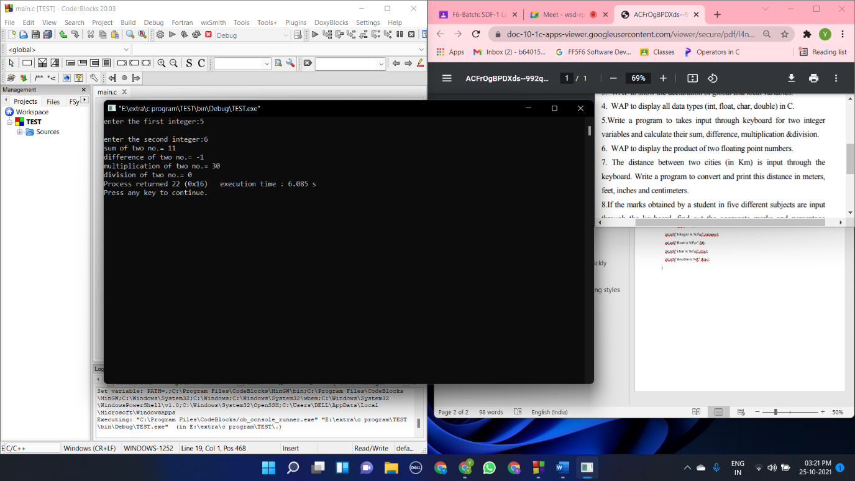 scanf("%d",&a);

printf("\nenter the second integer:");

scanf("%d",&b);

sum=a+b;

diff=a-b;

mult=a*b;

divd=a/b;

printf("sum of two no.= %d\n",sum);

printf("difference of two no.= %d\n",diff);

printf("multiplication of two no.= %d\n",mult);

printf("division of two no.= %d",divd);

}

Question 6

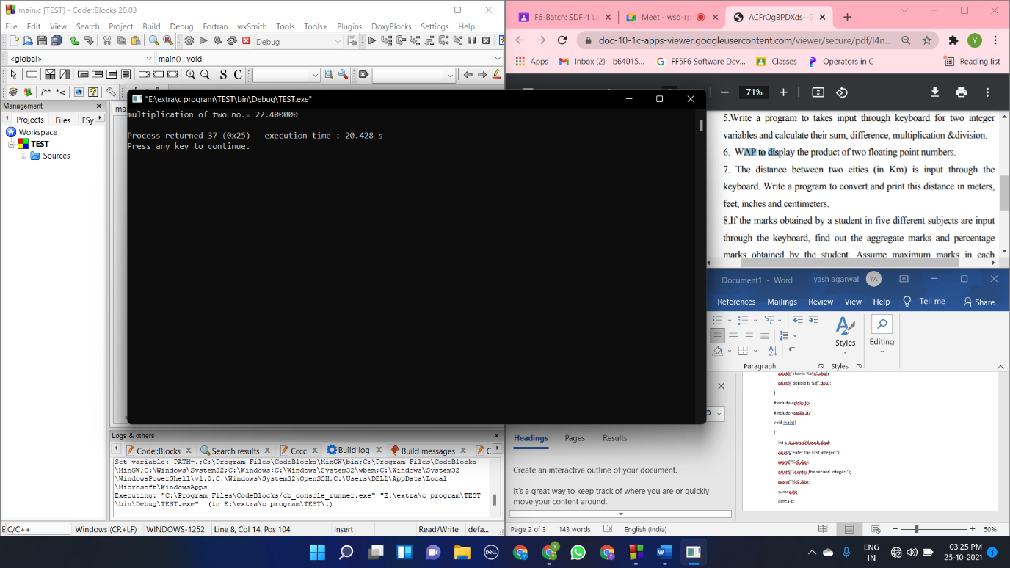#include <stdio.h>

#include <stdlib.h>

void main()

{

float a=3.5 ,b=6.4,mult;

mult=a*b;

printf("multiplication of two no.= %f\n",mult);

}

Question 7

#include <stdio.h>

#include <stdlib.h>

void main()

{

int dist;

printf("distance btw two cities is (in km):");

scanf("%d",&dist);

km_feet(dist);

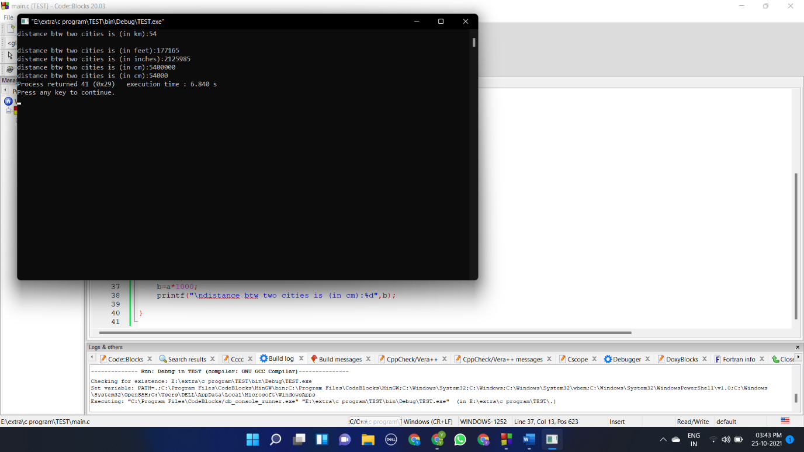 km_inc(dist);

km_cm(dist);

km_m(dist);

}

void km_inc(int a)

{

int b;

b=a*39370.1;

printf("\ndistance btw two cities is (in inches):%d",b);

}

void km_feet(int a)

{

int b;

b=a*3280.84;

printf("\ndistance btw two cities is (in feet):%d",b);

}

void km_cm(int a)

{

int b;

b=a*100000;

printf("\ndistance btw two cities is (in cm):%d",b);

}

void km_m(int a)

{

int b;

b=a*1000;

printf("\ndistance btw two cities is (in cm):%d",b);

}

Question 8

#include <stdio.h>

#include <stdlib.h>

void main()

{

int a,b,c,d,e,sum;

float perc;

printf("marks in sub 1:");

scanf("%d",&a);

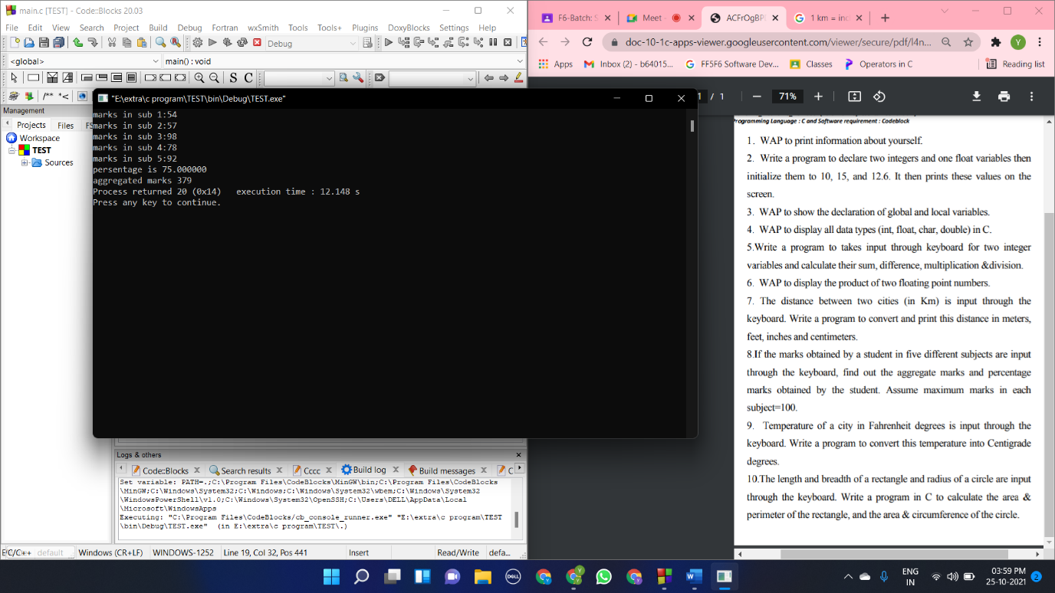 printf("marks in sub 2:");

scanf("%d",&b);

printf("marks in sub 3:");

scanf("%d",&c);

printf("marks in sub 4:");

scanf("%d",&d);

printf("marks in sub 5:");

scanf("%d",&e);

sum=a+b+c+d+e;

perc = (a+b+c+d+e)/5;

printf("persentage is %f\n",perc);

printf("aggregated marks %d",sum);

}

Question 9

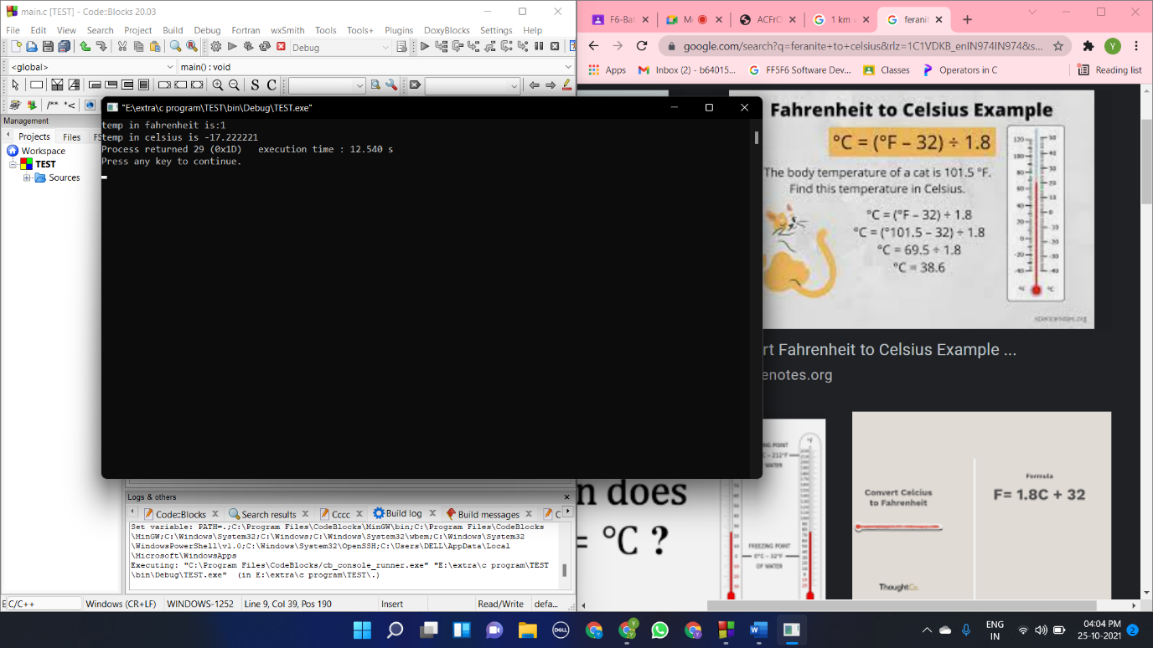#include <stdio.h>

#include <stdlib.h>

void main()

{

float a,b;

printf("temp in fahrenheit is:");

scanf("%f",&a);

b=(a-32)/1.8;

printf("temp in celsius is %f",b);

}

Question 10

#include <stdio.h>

#include <stdlib.h>

void main()

{

int l,b,r;

float arr,pr,c,arc;

printf("length of rect:");

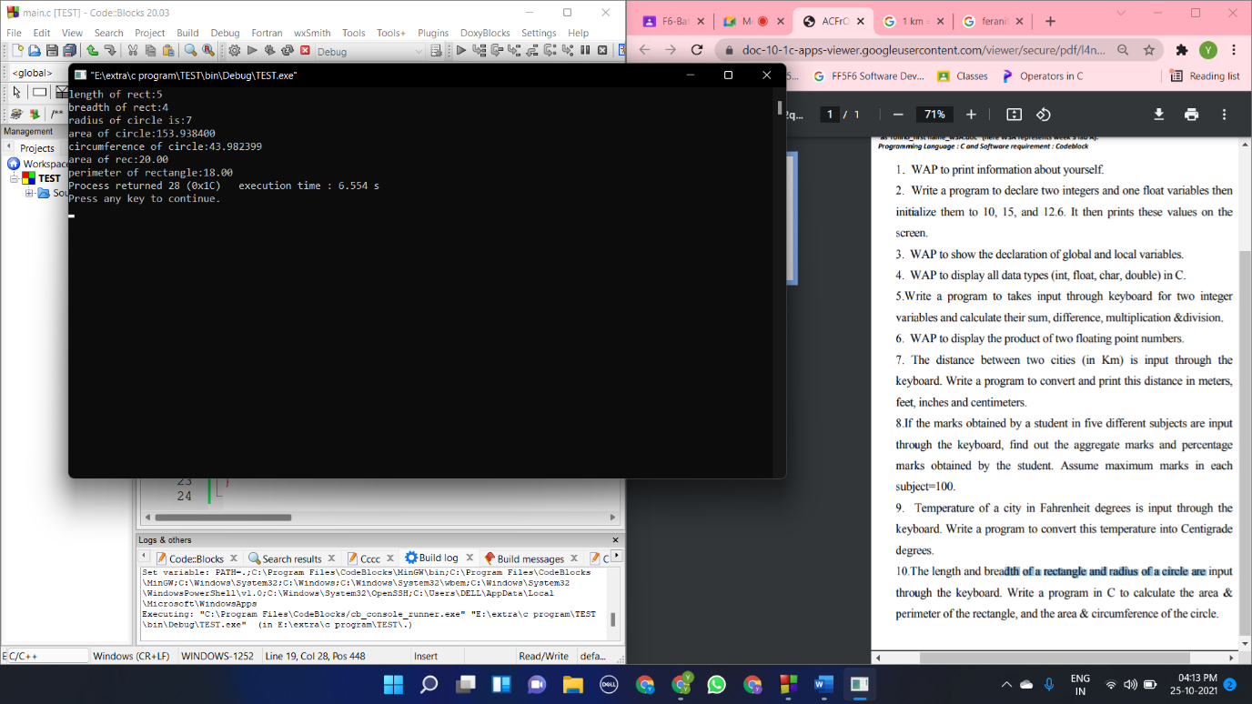 scanf("%d",&l);

printf("breadth of rect:");

scanf("%d",&b);

printf("radius of circle is:");

scanf("%d",&r);

arr=l*b;

pr=2*(l+b);

arc=3.1416*r*r;

c=2*3.1416*r;

printf("area of circle:%f\n",arc);

printf("circumference of circle:%f\n",c);

printf("area of rec:%.2f\n",arr);

printf("perimeter of rectangle:%.2f",pr);

}